The lion sleeps tonight

Stem 1
C 4 tellen F 4 tellen
Wimoweh Wimoweh Wimoweh Wimoweh
C 4 tellen G 4 tellen
Wimoweh Wimoweh Wimoweh Wimoweh

Stem 2
C F C G
Ahhh wieee…..ah wieaaa wieaaawambaweeeee

Stem 3: Couplet 1
C F
In the jungle the mighty jungle
C G
the lion sleeps tonight
C F
In the jungle the quiet jungle
C G
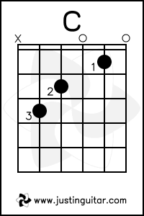
the lion sleeps tonight

Stem 3: Couplet 2
Near the village the peaceful village
the lion sleeps tonight
Near the village the quiet village the lion sleeps tonight

Stem 3: Couplet 3
Hush my darling don’t fear my darling
the lion sleeps tonight
Hush my darling don’t fear my darling
the lion sleeps tonight

Ukelele
Akkoorden piano
C = C E G
F = F A C of C F A
G = G B D of D G B

Gitaar Basgitaar
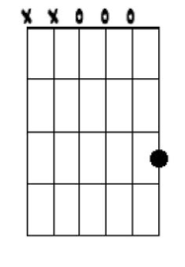
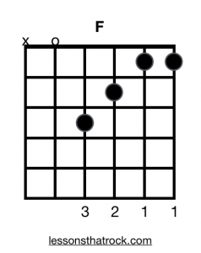
F G

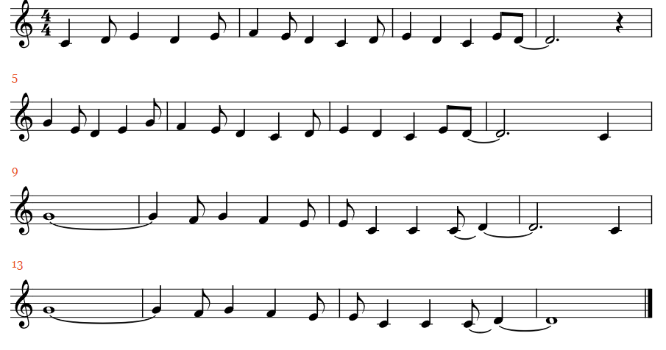
The lion sleeps tonight
Melodie

